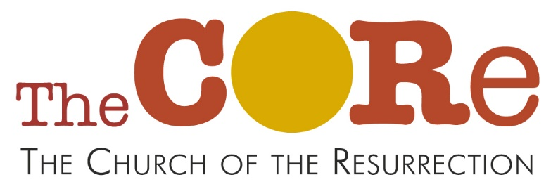
Churchway, SK10 3HT
Easter Fun Afternoon
Saturday 12th April 2-4pm
Crafts, stories and games to help children understand Easter
For children aged 5-11, accompanied by a parent or responsible adult.
Crafty activities will be messy so old clothes are a good idea.
All free. Places are limited. Please sign up using the form below
- - - - - - - - - - - - - - - - - - - - - - - - - - - - - - - - - - - - - - - - - - - - - - - - - - - - - - - -
Registration Form
CORE Easter Fun Afternoon, 12/4/24 at 2pm

Name and age(s) of child / children

Name of accompanying parent / responsible adult

Contact tel number:
Email address if possible:
Any allergies / food intolerances / health issues we should be aware of?
I give my permission for my child to attend this event
Signature of parent:

Please return this form to the Upton Priory School Office, or scan and email to core.upton@gmail.com, or post into the church letterbox. Thank you.

